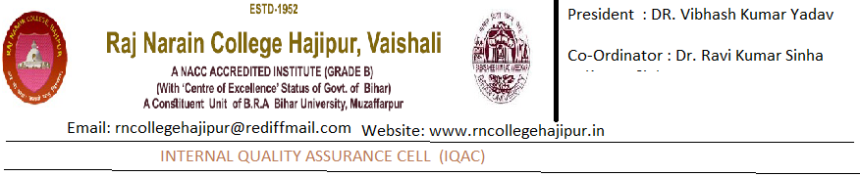

7.2.1 – Describe at least two institutional best practices

Title of the Practice:
Women Empowerment through inclusive and positive education.
Goal: Women Empowerment as part of overall Mission of providing inclusive quality education to educationally backward rural students, is one area distinctive to the Vision and Thrust of Raj Narain College, Hajipur.
The Administration as well as the faculties of the College shre the feelings that women deserve an equal space and place in all social affairs. Hence the College organizes special programmes for female students such as Guest lectures to create awareness among them on various law protections that are there for women against crime and injustices. The IQAC and the Gender Sensitization Cell conduct Workshops/ Seminars/ Invited Talks to create awareness among both male and female students towards their responsibility in creating a social environment free from gender bias violence against women.
With a view to realizing this vision, seminars have been organized on (i) Reading as a Woman: Feminism in India (ii) a Panel Discussion on Womens Rights on the occasion of International Womens Day, and (iii) a Webinar on Contextualizing Gender Issues.
Notably, in all Cultural events and Programmes, female students are encouraged to take part in leading roles, and they successfully anchor and conduct the Academic Sessions of Seminars also.
In Sports also, despite coeducational environment, female students participate in all sports and games / Annual Meets, and outnumber as well as excel male students.
The Womens Kabbadi Team of Hajipur has won Second Position at the University Level Meet, and four of them have been selected in the University Kabbadi Team.
All these activities and initiatives have substantially and qualitatively changed the academic and social skills not only the female students, but has also the biased mindset of male students.

2. Title of the Practice:
Community Library for underprivileged children in the surrounding areas of R.N. College, Hajipur (Bihar)
Goal:
Library constitutes the hub of the entire educational edifice, where the students explore the world of ideas and substantiate their own worldview. A rich library also provides liberating experience from the monotonous study of prescribed textbooks, and contributes towards the inculcation of research aptitude in the inquisitive mind of the youth. Even at an early stage, if children are encouraged to visit the library with fascinating titles, in tune with their tender age, aptitude, likes and dislikes, it is observed that they unconsciously turn away from the ‘uncreative pastime activities’. They also acquire positive values through their reading habits.
However, a survey of the local government schools revealed that they do not have libraries worth the name, nor are children encouraged to read storybooks, comics, cartoons, child magazine such as Champak, Nandan, Chandamama, etc. No wonder, children from these underprivileged sections develop distaste for ‘books’ and gradually an aversion of academic pursuit at later stage, leading to higher drop out ratio. It is hoped that an earlier initiation of these children in library reading will not only transform them into better creative human being, but will also induce them for pursuing higher education, which will go a long way in achieving their ‘inclusive growth’.
The Practice:
The Library has been set up entirely with the donated children books, children magazines and interesting reading materials. 2.The teachers of the College, taking interest in this project, voluntarily donated books and magazines and also made collections from known sources. 3.Some teachers even made monetary contributions for this project. 4.The Space for stacking and reading facilities have been provided in the campus by the College administration.
The working of the Community Library has been institutionalized with the constitution of a committee of four teachers and one support staff. The staff is entrusted with the work of opening the gate of the Library, which runs in the evening hours (between 4 to 6 p.m.). 6. A committee of the member-children has been constituted, which takes care of books/magazines and their distribution among the readers.
Evidence of success:
Despite the fact that the ‘community library’ has covered a very short period of time, it has generated a positive response in the children of the locality, who every evening enthusiastically come to read the books and magazine of their choice. The smooth way in which they manage the upkeep of the reading materials and maintain the discipline is remarkable, and demonstrate their ‘talent’. Some of the children have demanded that latest magazines should also be made available, which is indicative of their growing interest in written materials.
Problems encountered and Resources required:
In order to procure suitable and interesting books and latest magazines for the children, the Working Committee for the Community Library has decided to contact generous persons, government organizations and also National Book Trust of India for support.

